**MySQL QUERIES**

**A. EDA**

**1. Overview:**

select * from layoffs;

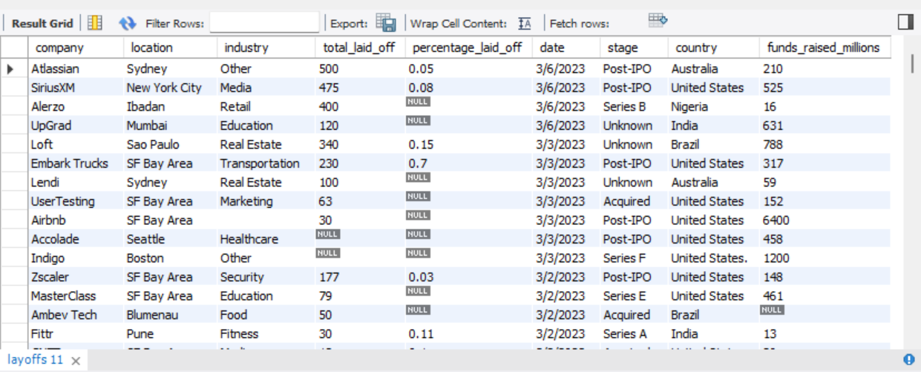

**2. 100% laid-off companies by total laid off**

SELECT

*

FROM

layoffs

WHERE

percentage_laid_off = 1

ORDER BY total_laid_off DESC;

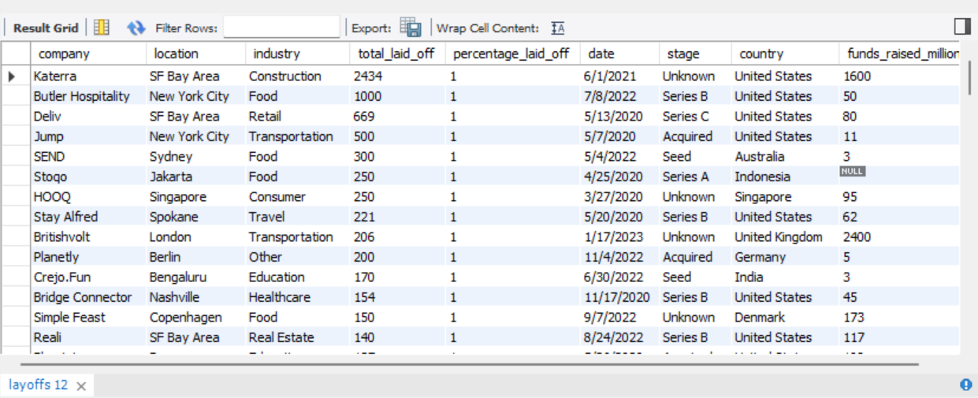

**3. . 100% laid-off companies by highest funding**

SELECT

*

FROM

layoffs

WHERE

percentage_laid_off = 1

ORDER BY funds_raised_millions DESC**;**

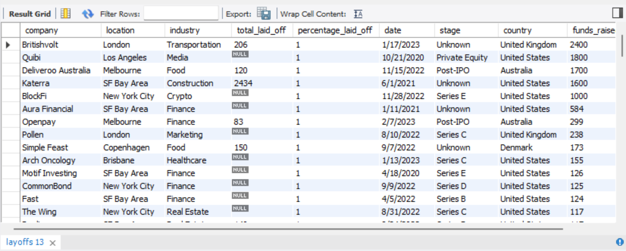

**4. Total laid off by the company**

SELECT

company, SUM(total_laid_off)

FROM

layoffs

GROUP BY company

ORDER BY 2 DESC;

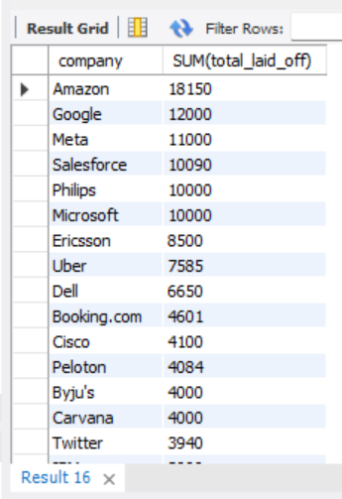

**5. Find the duration of the data**

select min(new_date), max(new_date) from layoffs;

**6. Total laid off by the company**

SELECT

company, SUM(total_laid_off) as total_laidoffs

FROM

layoffs

GROUP BY company

order by total_laidoffs desc;

**7. Total layoffs by industry**

SELECT

industry, SUM(total_laid_off) as total_laidoffs

FROM

layoffs

GROUP BY industry

order by total_laidoffs desc;

**8. How many people lost their job by country**

SELECT

country, SUM(total_laid_off) as total_laidoffs

FROM

layoffs

GROUP BY country

order by total_laidoffs desc;

**9. Rolling total of laid off month by month**

with Rolling_total as

(

SELECT SUBSTRING(new_date, 1, 7) as `MONTH`, SUM(total_laid_off) as total_offs

FROM layoffs

where SUBSTRING(new_date, 1, 7) is not null

group by `MONTH`

order by 1 asc)

select`MONTH`, total_offs, sum(total_offs) over(order by `MONTH`) as rolling_total

from Rolling_total;

**5. Top 5 companies’ ranking by years with higher laid offs**

With Company_Year (Company, Years, Total_laid_off) as

(

SELECT company, YEAR(`new_date`), SUM(total_laid_off)

FROM layoffs

GROUP BY company, year(`new_date`)

), Company_Year_Rank as

(

select *, dense_rank() over (partition by years order by Total_laid_off desc) as ranking

from Company_year

where years is not null)

Select *

from Company_Year_Rank

where ranking <= 5;

